
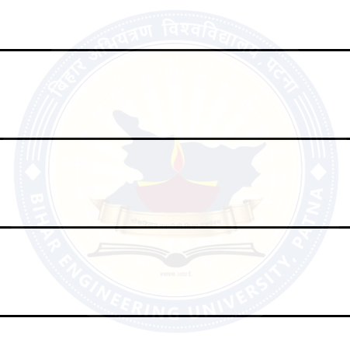
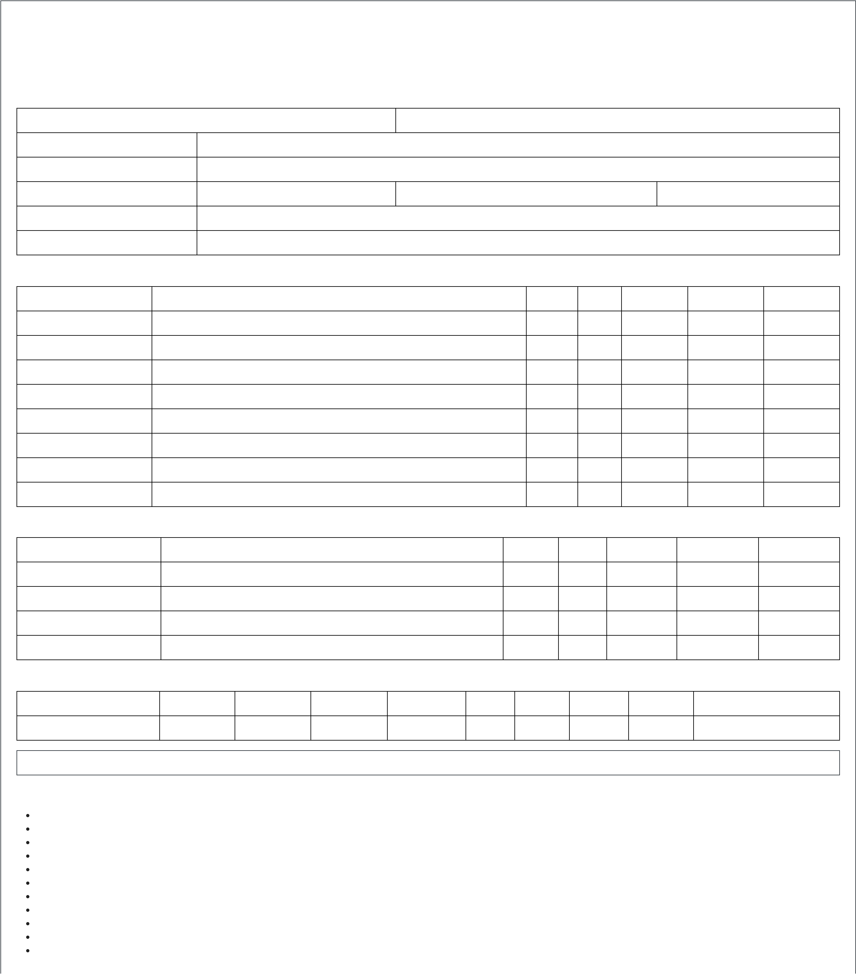
BIHAR ENGINEERING UNIVERSITY, PATNA
B.Tech. 4th Semester Examination, 2025
Semester: IV | Examination (Month/Year): December/2025 |  | MALTI DEVI
Registration No: | 23101106007
Student Name: | ATENDRA KUMAR
Father's Name: | ARJUN CHAUDHARI | Mother's Name:
College Name: | 106 - SITYOG INSTITUTE OF TECHNOLOGY, AURANGABAD
Course Name: | 101 - CIVIL ENGINEERING
THEORY
Subject Code | Subject Name | ESE | IA | Total | Grade | Credit
101401 | Civil Engineering - Societal & Global Impact | 45 | 29 | 74 | B | 2
101402 | Disaster Preparedness & Planning | 39 | 29 | 68 | C | 2
101403 | Introduction to Fluid Mechanics  BIHAR ENGINEERING UNIVERSITY, PATNA WEB COPY 9 Engineering Geology 14  Introduction to Solid Mechanics 36 |  | 29 | 43 | F | 2
101404 |  |  | 29 | 38 | F | 3
101405 |  |  | 25 | 61 | C | 3
101406 | Materials, Testing & Evaluation | 37 | 28 | 65 | C | 2
101407 | Mechanical Engineering | 39 | 27 | 66 | C | 3
101408 | Structural Analysis | 7 | 23 | 30 | F | 4
PRACTICAL
Subject Code | Subject Name | ESE | IA | Total | Grade | Credit
100408P | MOOCs / SWAYAM / NPTEL Courses - 1 | AB | AB | 0 | F | 2
101403P | Engineering Geology | 24 | 19 | 43 | A | 1
101404P | Introduction to Fluid Mechanics | 24 | 19 | 43 | A | 1
101406P | Materials, Testing & Evaluation | 23 | 19 | 42 | A | 1
SGPA / CGPA
Semester | I | II | III | IV | V | VI | VII | VIII | Cur. CGPA
SGPA | 7.23 | 7.02 | 7.96 | 4.35 | - | - | - | - | 6.53
Remarks: FAIL:100408P,101403,101404,101408
Note:
ESE: End Semester Exam
IA: Internal Assessment
SGPA: Semester Grade Point Average
CGPA: Cumulative Grade Point Average
AB: Absent
NA: Not Applicable
N/A: Not Available
*: Passed Under Regulation(UR)  CA: Cancellation of Assessment  UMC: Unfair Mean Case | accessibility
WEB COPY: Not valid for official purpose.

University does not own for errors or omissions, if any, in the statement.
WEB COPY
accessibility

